On autonomous programming for phototaxis

Study guide

Christopher A. Tucker

*Cartheur Robotics, Prague, Czech Republic*

c.a.tucker@cartheur.com

# Synopsis

This document is designed to compile the material to generate the paper *On autonomous programming for phototaxis*, an attempt at resolving the form and function of an autonomy study written for the Lego NXT robot *haden*.

Regardless if a whole robot is constructed or using an existing off-the-shelf platform, whether desiring to leverage an OS or throw commands against an API, the aim is the same: Cartheur Robotics needs a first look at its new product suites to prepare for what lies ahead. Whether controlled from a laptop or a mobile appliance, whether in C/C++/C# or Python, what form will the program take and from what constructs is it reliant upon? What can be made cogent and tangible in the vision and the first application of beauty?

# Compilation of notes from the diary

Compiled from the diary entries, 3 August to 27 September 2014.

1. Hardware is great, but what is the substance of that which manipulates it? (20140803)
2. A short-term goal of the implementation is a proof of the concepts presented in *Models of robotic feeding, choice, and the survival mechanism*.
3. A review of the NXT start in 2007 only serves to tell you where you began.
4. The scenario of seeking a lamp (phototaxis) is an ideal place to start, especially given Walter and your connection to his work first fostered in France in 2004. (20140811)
5. An approximation of Walter is a good place to start with your first attempt. A focus on scanning (A scanner darkly?) (20140815)
   1. Scanning – a form of behavior (sniffing, looking, listening, palpating) by which a sensory

stimulus is sought or expected, and which is guided by an expectancy of input instead of a future internal state (goal). The search must be broad in the sense of looking everywhere, but narrow in the sense of being specific as to the characteristics of the anticipated stimulus, which implies that the search is guided by memory of past experience, as distinct from a predicted goal or automatic guidance by a set point. From *Biographical Sketch: W Grey Walter* by Walter J Freeman, Encyclopedia of Cognitive Science (2003).

1. The first version of *M. Speculatrix*, shown in the diary, Fig. 11, is a good platform to begin with.
2. Following up with Owen Holland could be helpful for those aspects of the theory which match.
3. Bluetooth issue sorted for Dell laptop, Windows 7 x64. A reliable connection to the NXT is established.
4. Be certain to contain all the tools for the autonomy works:
   1. Laptop (W7x64)
   2. NXT
      1. Charger cable
   3. Charging station
   4. Wireless power area antennas (2)
   5. iPAQ (WM5)
      1. Charger cable
   6. Mio (WM5)
      1. Charger cable
   7. 5V miniature power supply
5. The C#.NET application *Haden.Remote* and *Haden.Remote.CF* is an excellent platform since the tools use WM5, when thinking of going completely mobile, although the laptop concept is pretty mobile in the current sense of the word.
   1. Notes regarding development are kept in the ProjectNotes.txt file in the project.
   2. One emphasis is on the autonomy application,
   3. One emphasis is on the autonomy simulator.
6. The experimental setup, using a battery-powered lamp, sans wireless recharging, is shown in Fig. 1. It is called “second-generation” following the original wheeled robot, which used the first generation software, shown in the diary, Fig. 13.
7. Use the notebook *Featured Power* alongside this digital document to contain thoughts.
8. Following the reconstruction-motivation centering around Walter (he declares he is more interested in proving neural constructs than purely robots, “a laboratory which invented the toposcope surely can create these tortoises”), write the program around a state diagram—perhaps a fresh one is in order—along the lines of one from the paper, appearing in Fig. 2.
9. **IMPORTANT**: autonomy “maps” in an attempt to compartmentalize the software execution. Shown in Fig. 3. Here is the mathematical representation of the logic flow:
   1. Obtain current sensor value, store as optimum value, 
   2. Store the value for later comparison operation,
   3. Flip a coin to decide which seek-move to make: left or right,
   4. Move an angle, of step-granularity 
   5. Obtain current sensor value, 
   6. Perform the operation: 
   7. If  move in the same direction an angle of step-granularity 
   8. If  move in the opposite direction an angle of step-granularity 
   9. If  move in the same direction as the previous move,
   10. When  ???
10. Leverage the simulator, with its flashing buttons where possible. An alternative is to incorporate the button flashing in the physical model as a way to communicate to an observer of autonomy.
11. Reassess the code from the point of view of this *Study guide*. (20140903)
12. GDI+, although a roaring success, is only to be investigated once autonomy is solved. (20140923)
13. Perhaps some helpful experiential notes of coding the autonomy in the API. (20140927)
14. Perhaps some helpful experiential notes of the development of the hardware for the wireless recharging platform. (20140928)

Words.

# The theory on the present set of states in the assumption

Words.

# Fundamental behavior in autonomous programs

Goal-based routines are prolific in the literature [SOURCES]. What is interesting to consider between these is programs which serve the interests of the robot, such as feeding, while allowing full autonomy in how the goal is obtained. An example which is sufficiently complex yet simple enough to be described diligently is behavior exhibited in *phototaxis*.

# Figures

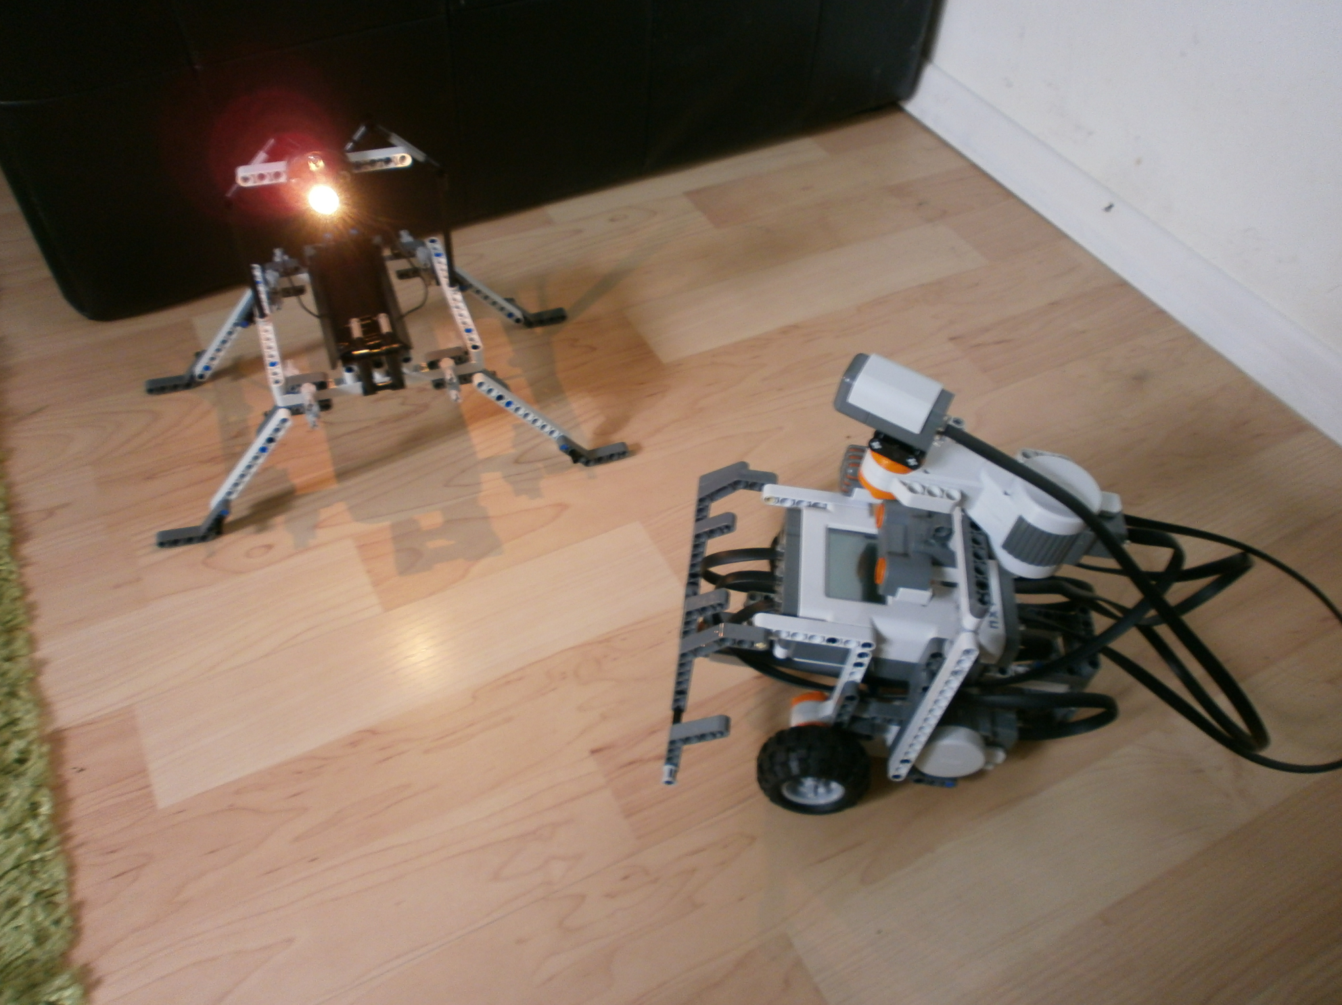

Fig. 1. Second-generation haden (*M. Speculatrix*) with its feeding station.

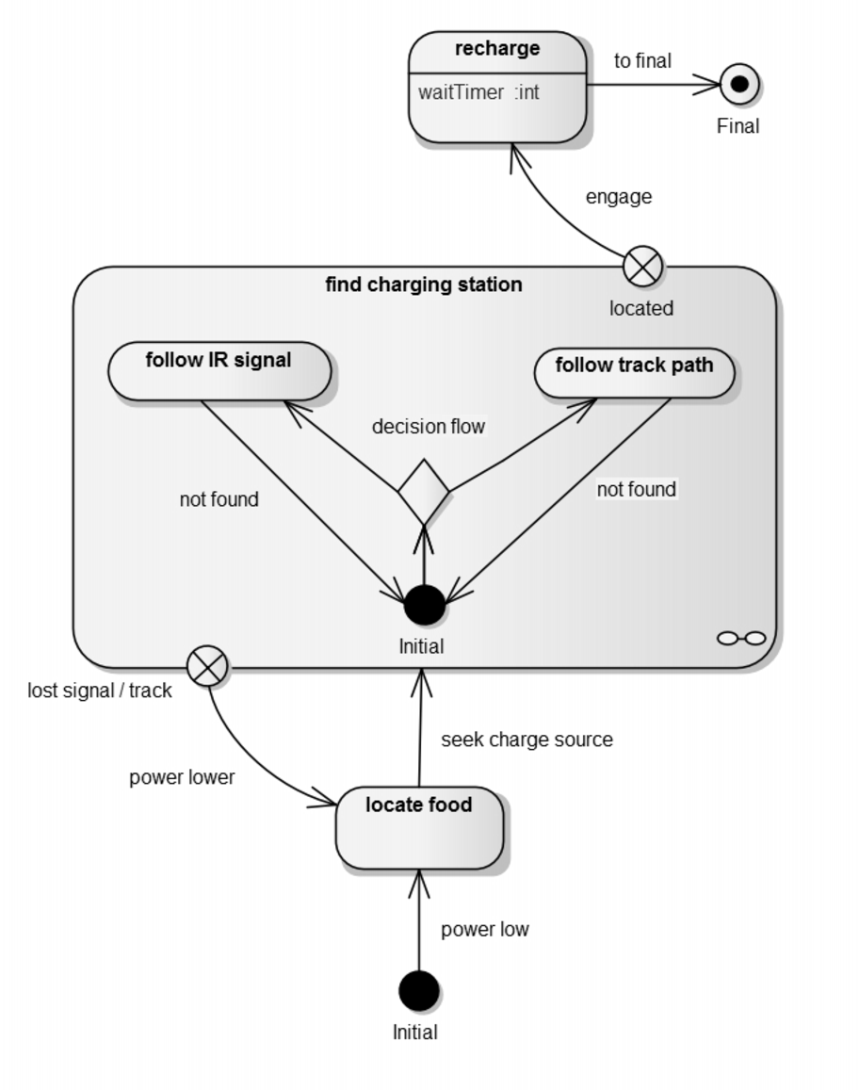

Fig. 2. State transitions for feeding via a station.

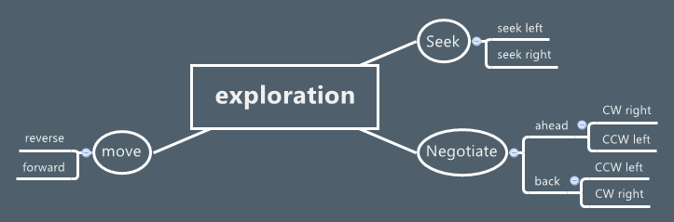

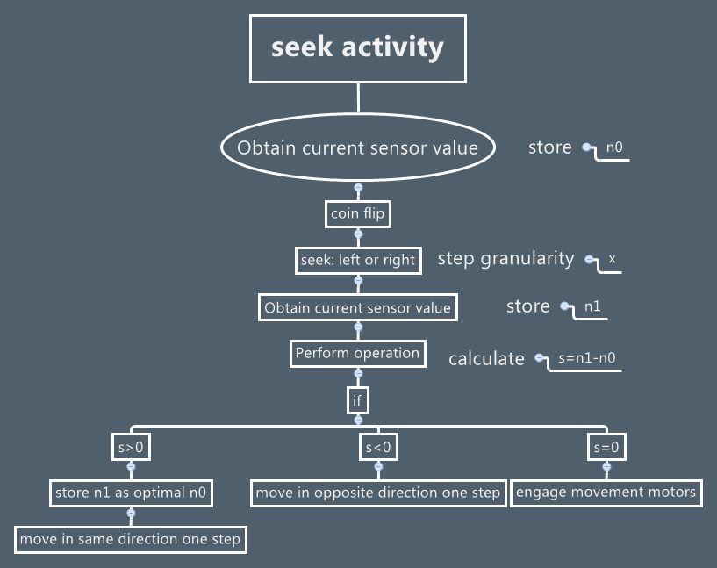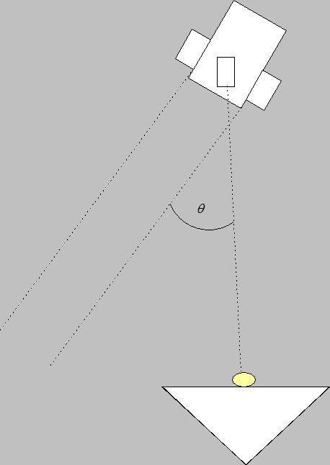

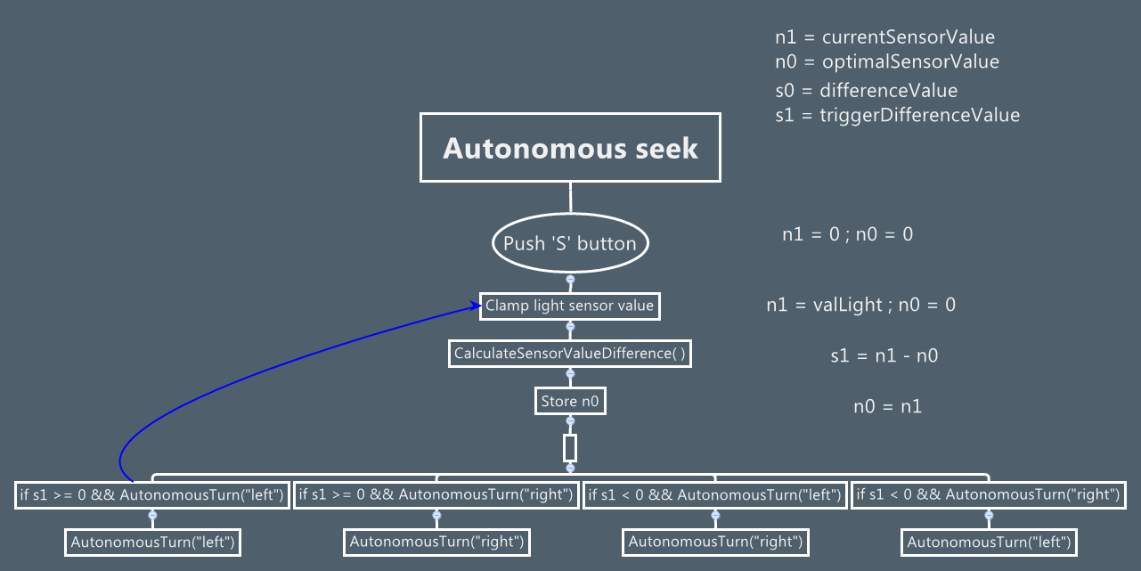

Fig. 3. Compendium of compartmentalizing the autonomy routines.

# References

1. C.A. Tucker, “Haden controller in C#,” *arXiv*, doi: sum, Sep. 2014.
2. C.A. Tucker, *Wireless power by magnetic resonance,* Berlin: Scholar’s Press, 2014.